This is how I add rear facing USB to a cheap deck I got from Craigslist for $40.
I use an iPhone, filled with music. I added a line on my cell phone plan for $10 a month, which gives the phone internet access anywhere. Giving access to Pandora, Spotify or whatever.
The reasons I use an iPhone are because it gives me Apple Maps for GPS and it also gives me Find my iPhone, in case my car gets stolen, I can use it to find my car. If you only want it for music and find my iPhone, you can even hide the iPhone behind the deck (or run a long wire to the trunk, or some other well-hidden place) so the car thieves won’t know it’s there right away. Giving you time to track it. In the case of my 944, I created a custom, laser cut bezel to replace the sunglasses cubby.
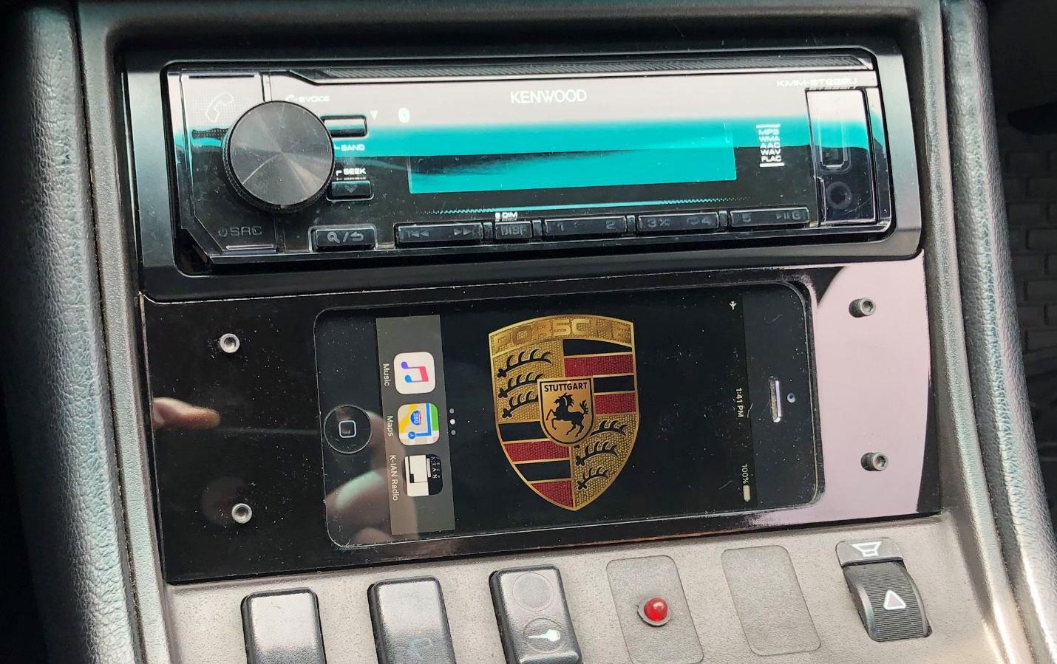

I could just plug the cable in the front port, but I hate the look of the wires. It just looks like butt.
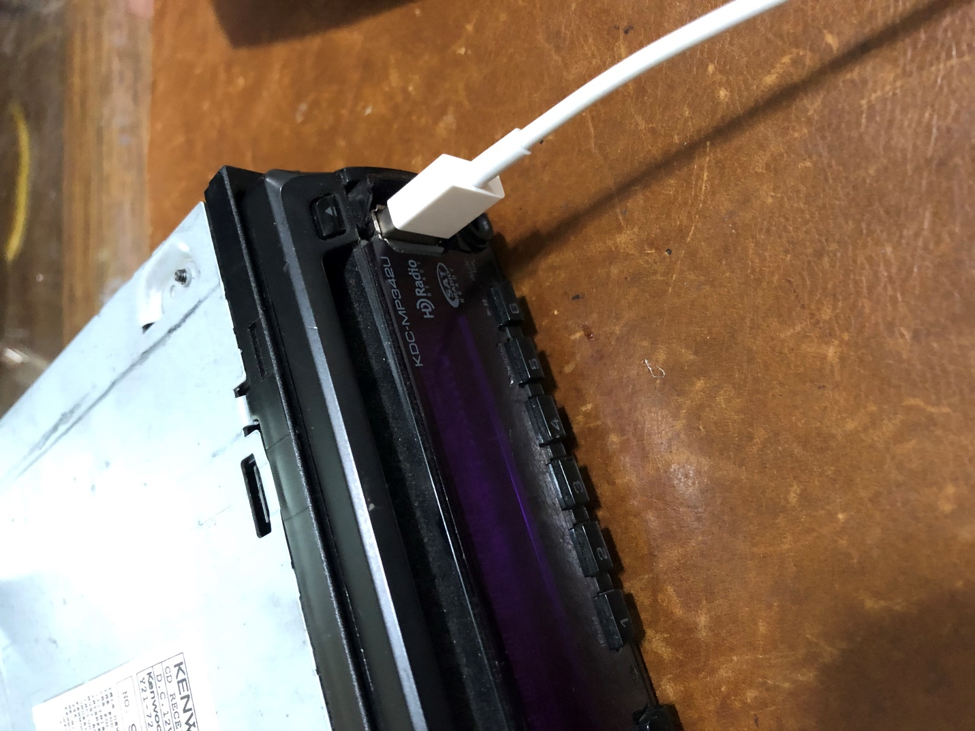

First, you need to determine which pins are which. Compare the pins to the pinout.
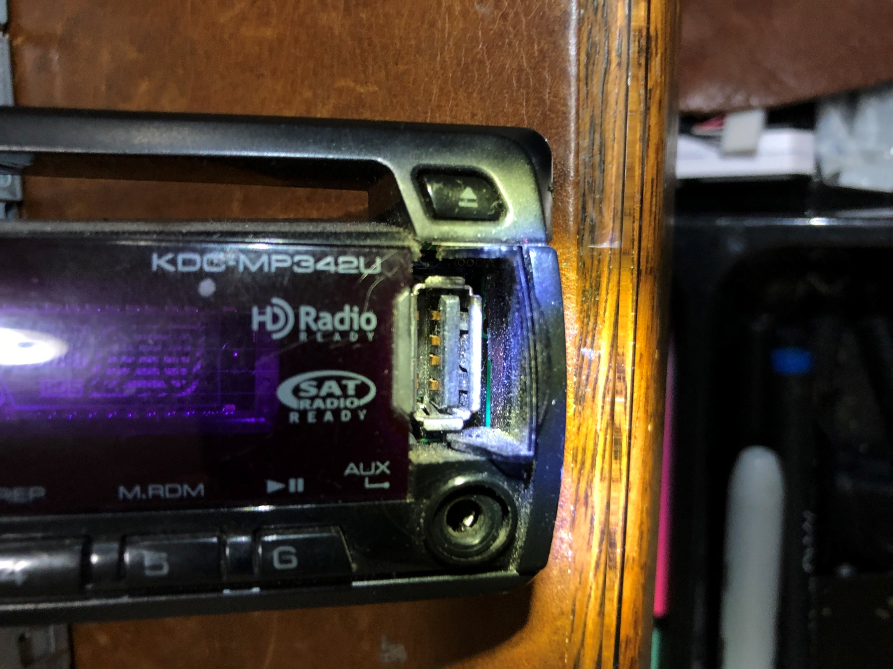
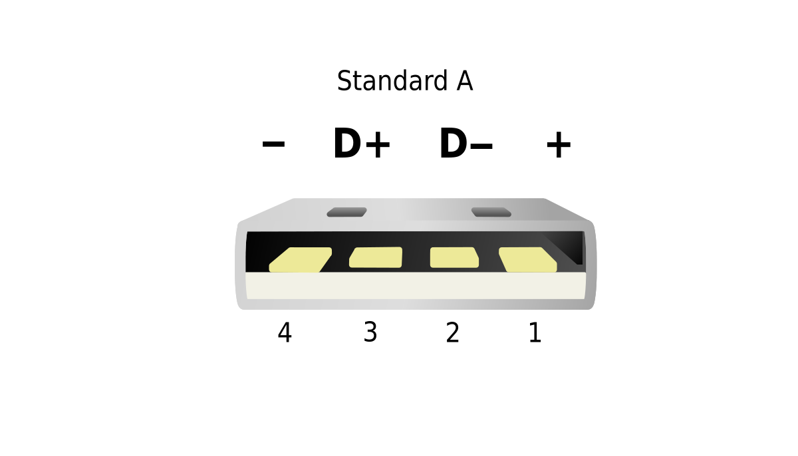
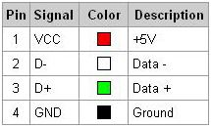

This is the reverse side.
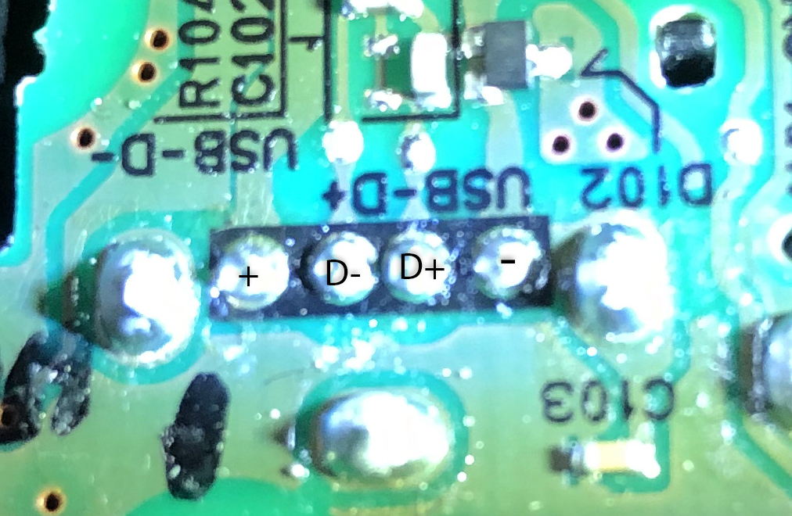

You want to use a USB extension cable. You could simply use a cable specifically for your device, iPhone, micro USB or USB C,
but then you are committed to that type of cable and if you ever want to change it, you have to go through all of this again.
By using a USB extension cable, it makes it universal and you can plug in any cable you want.

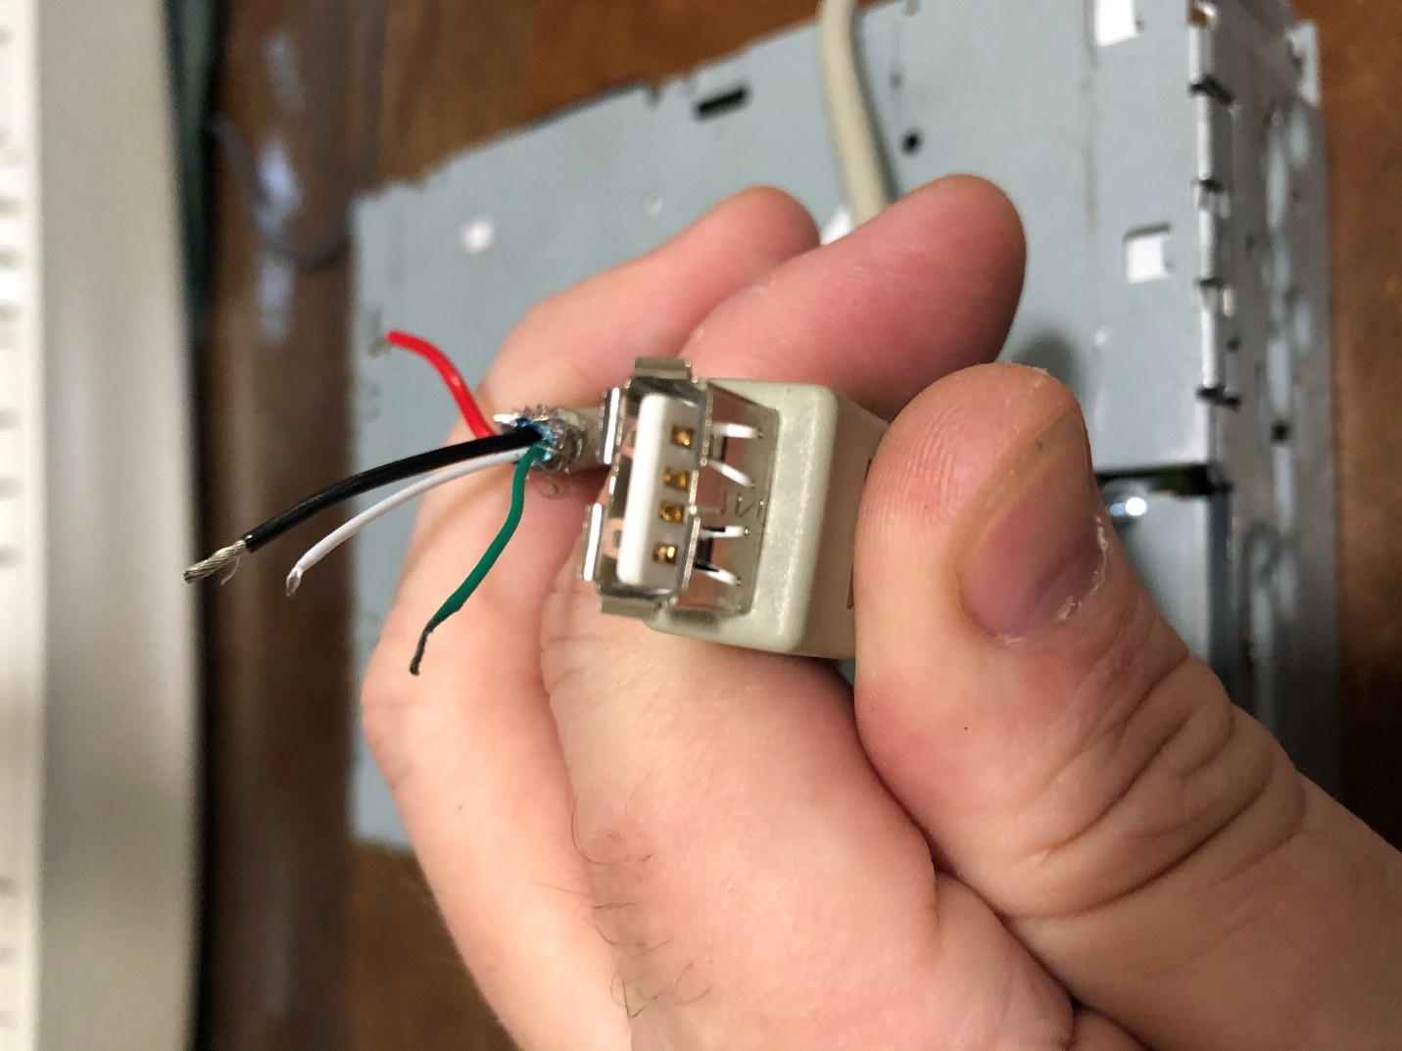

You want to remove the front plate of the deck and fish the cable from the rear to the front.
I got lucky on this deck and there was a gap in the back, large enough to fit the cable, but you might need to drill a hole.
Be very careful that you’re drilling into a place with nothing behind it.
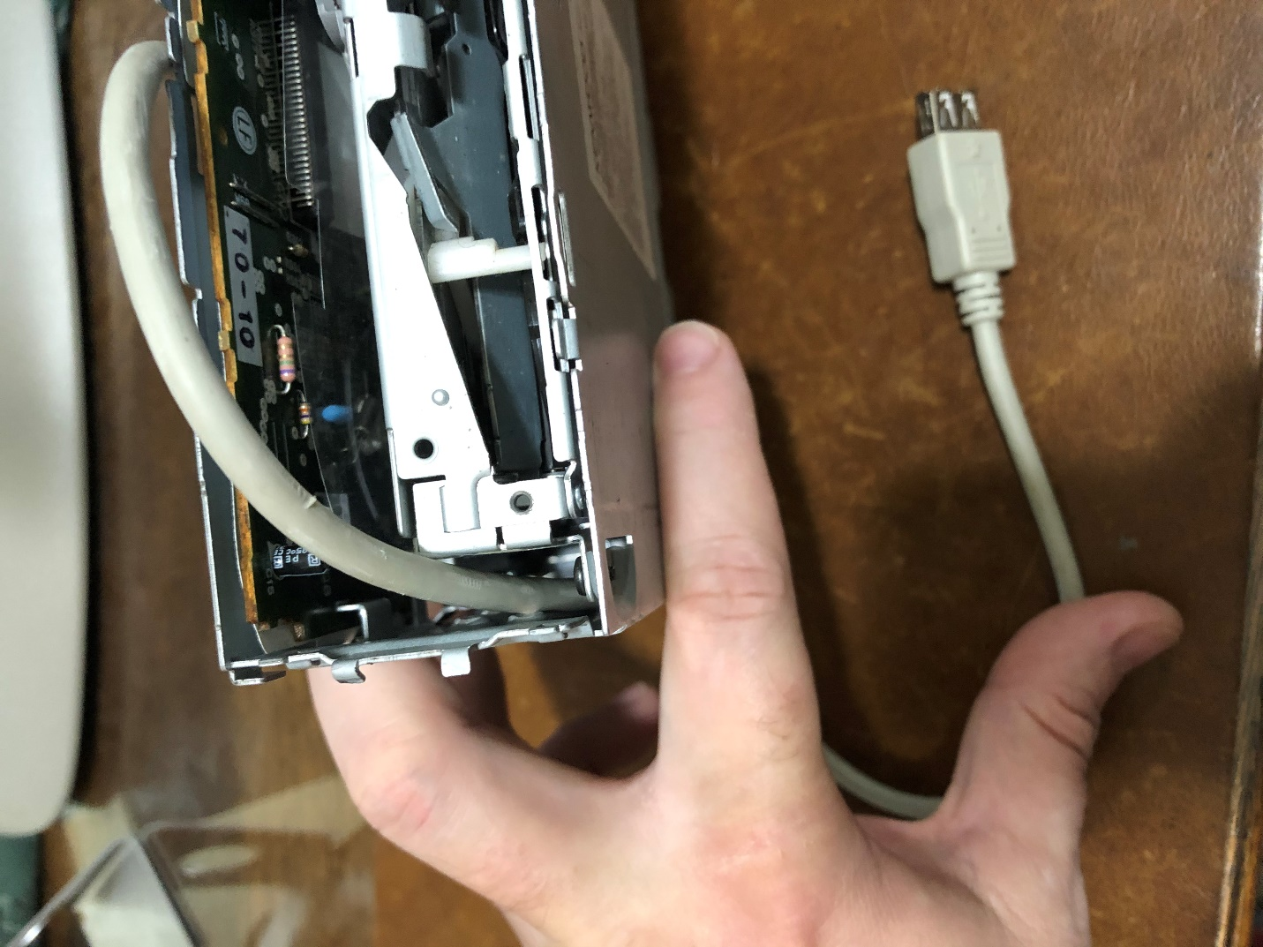

Unscrew the screws holding the faceplate together and separate the two halves.
Insert the faceplate back into the front of the deck
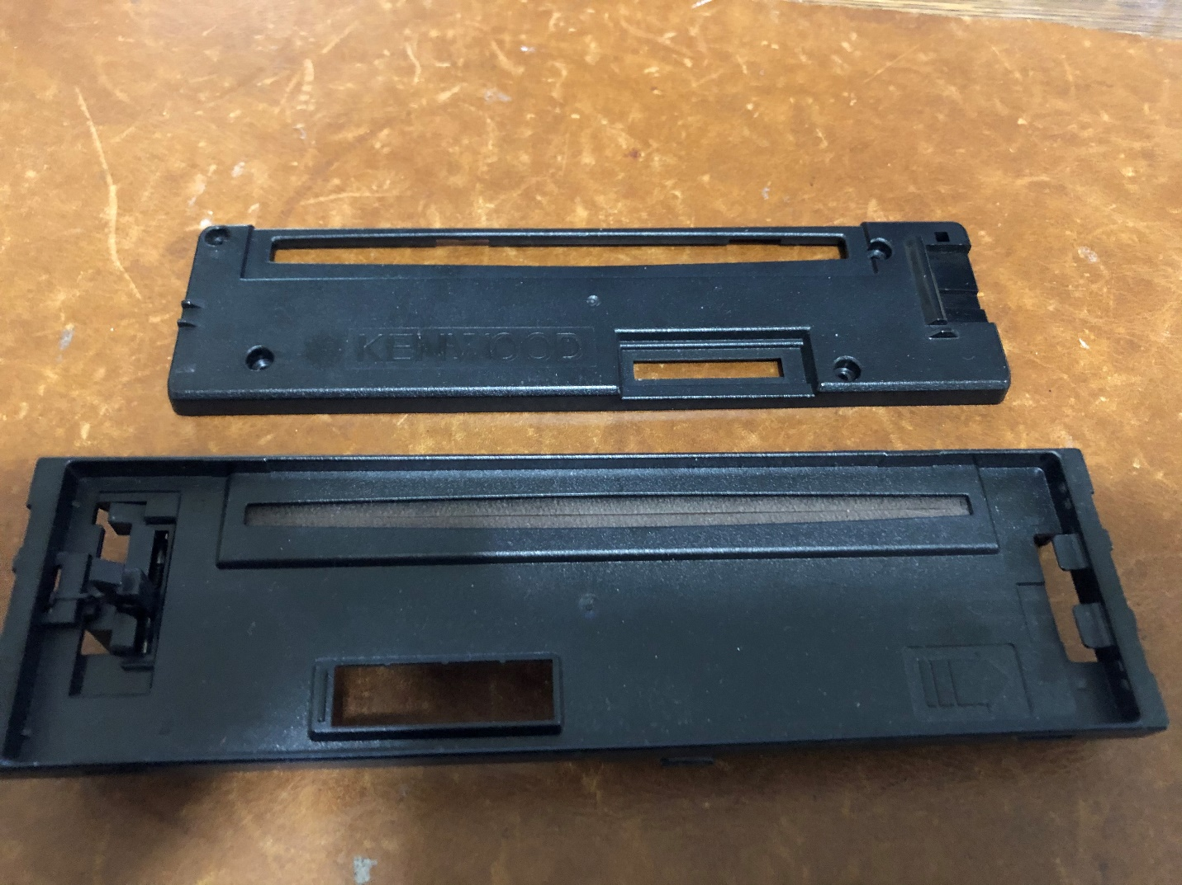
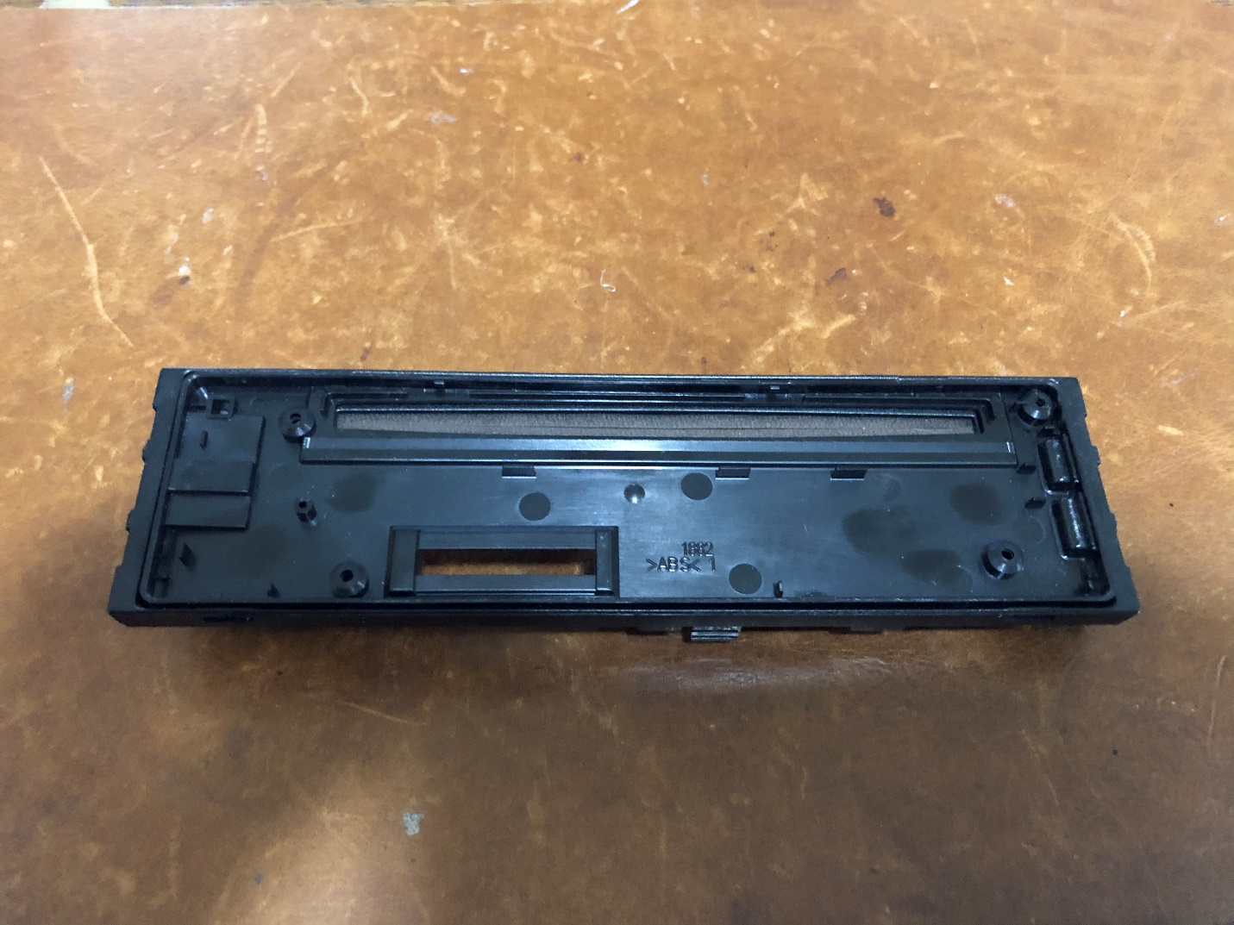
You need to drill a hole for the wires in the general area of the solder points and this puts the holes in the exact same spots.

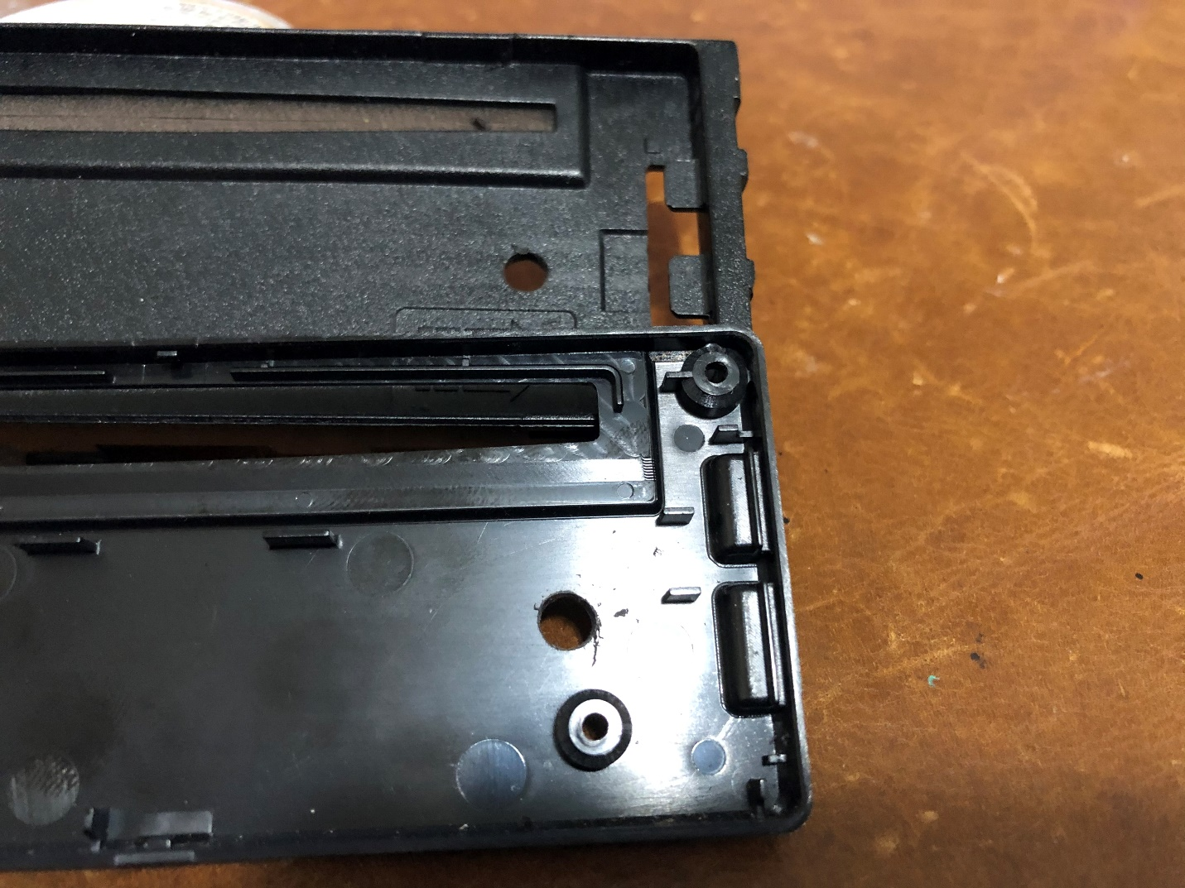

I like to remove the faceplate release pin so I don’t accidentally detach the face once it’s installed.
It won’t be a detachable face deck anymore and I don’t want it coming off and possibly stressing the wires or solder points.
If I need to take the faceplate off, I can use a paper clip.
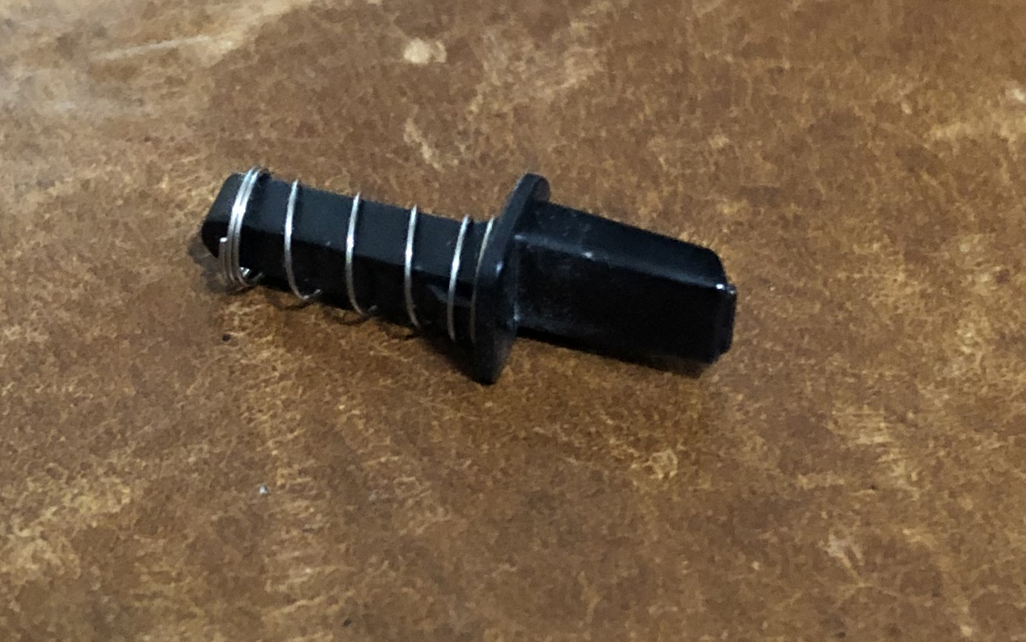

Fish the wire through them and make sure to allow lots of extra wire to make it easier to solder.
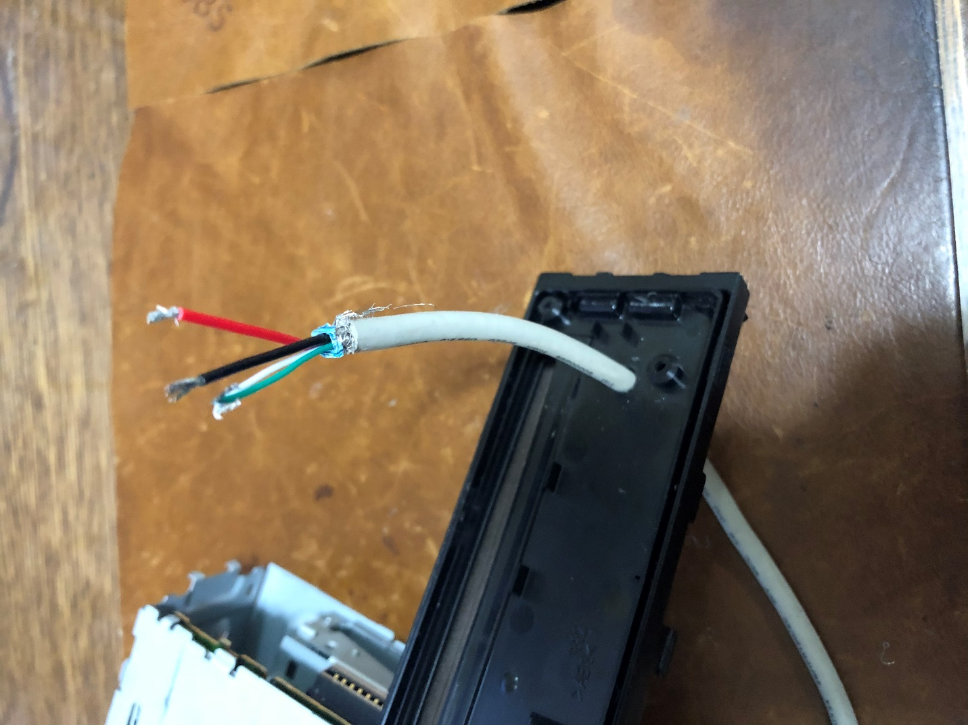

Flux and tin the wires. I like to clip off the very tip of the wires after tinning, so I have a clean,
flat tip of the wire so it will solder to the points more cleanly, while keeping as much of the wire insulated as possible.
Then, using a very fine soldering iron tip, solder the wires to the corresponding points, being very careful to not short anything together.
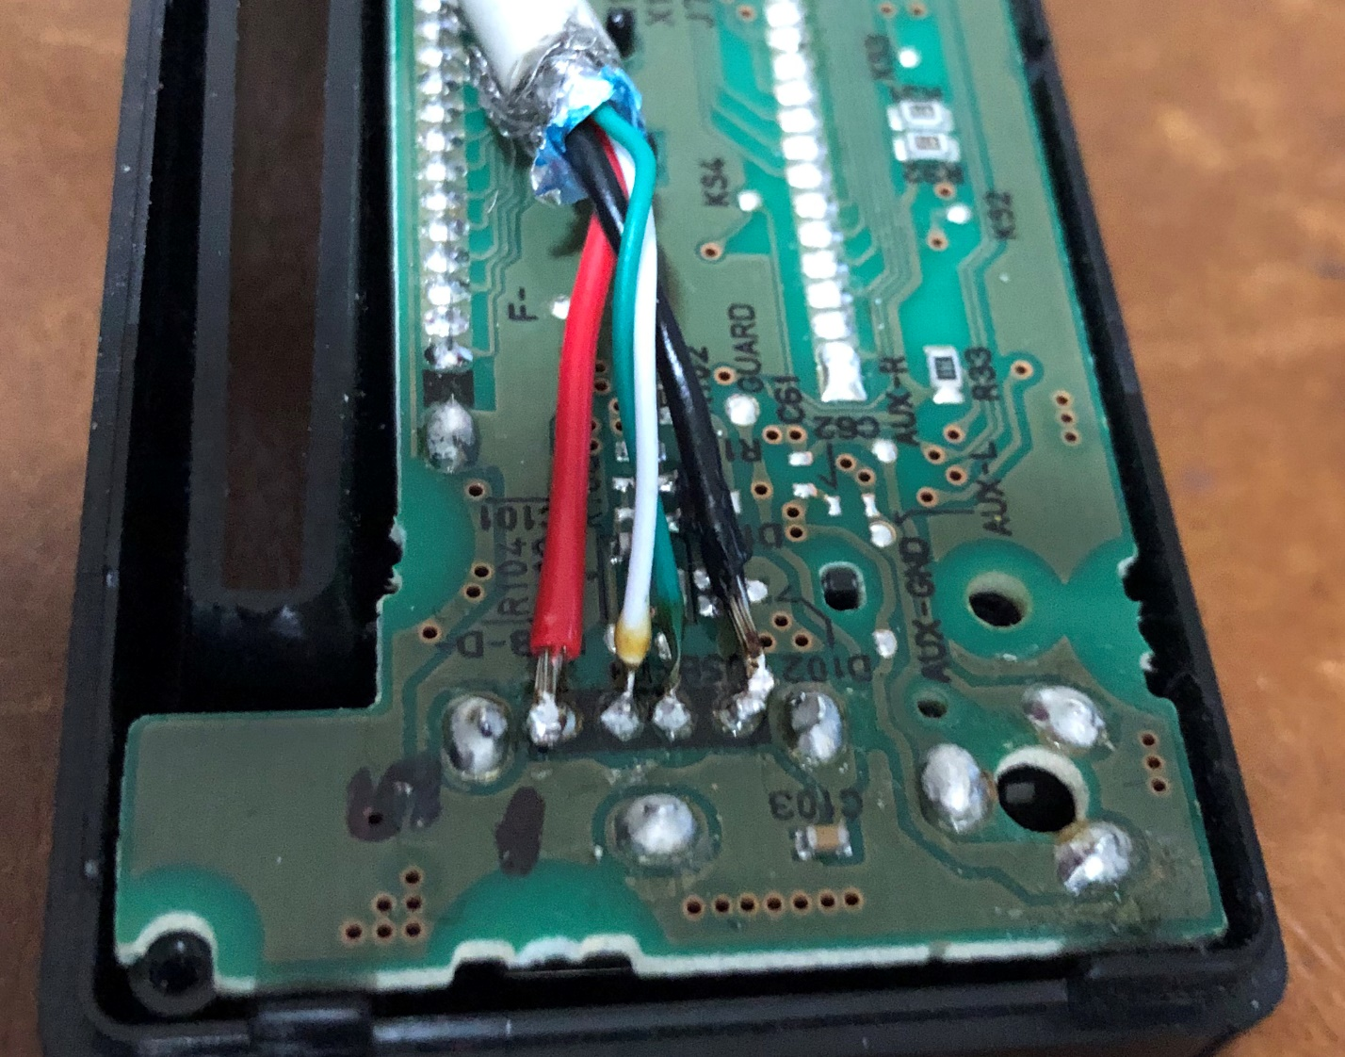

Carefully re-attach the back cover of the faceplate and replace the screws as well as the front deck plate.
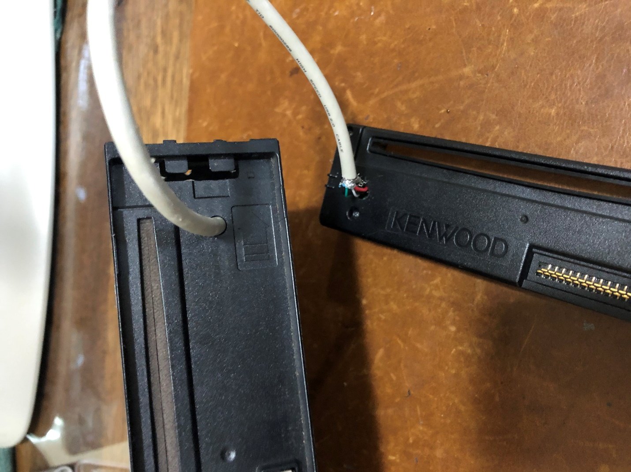

Then carefully pull the excess wire back from the back of the deck and clip the faceplate into place.
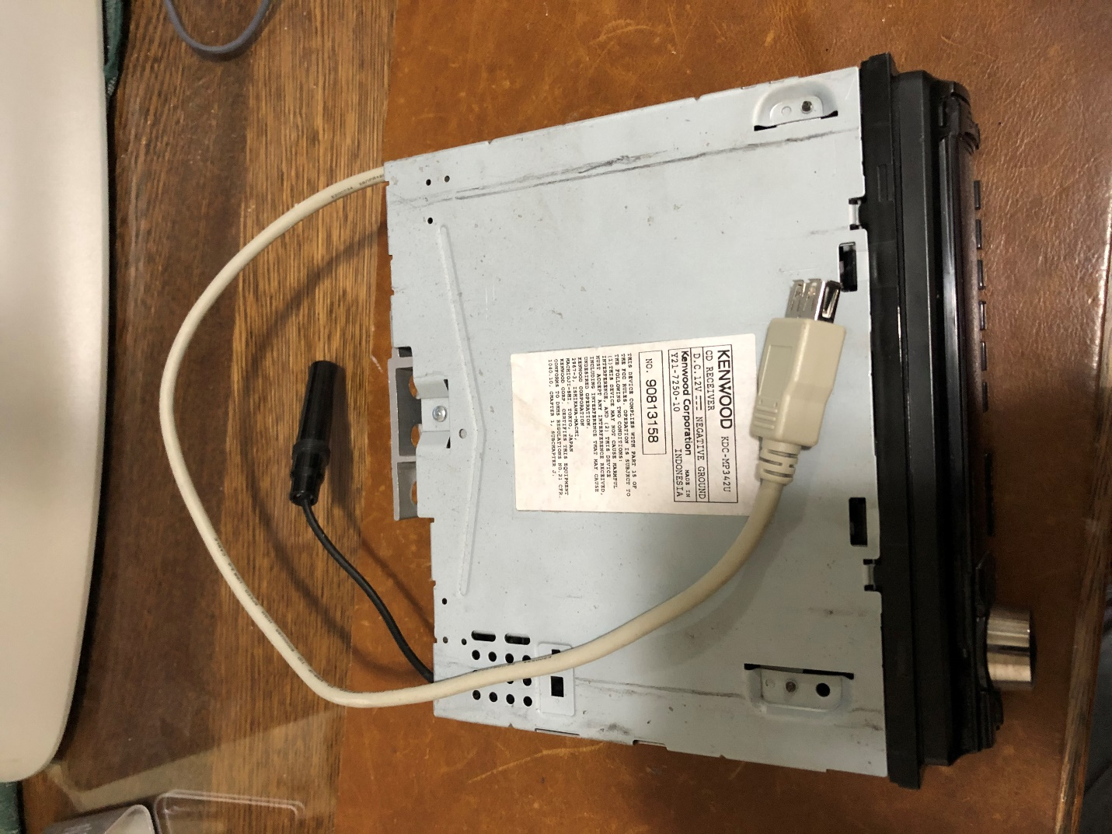

Now, test it all by either installing the deck or use a desktop power supply.
I don’t like to use my phone first for testing, in case I made a mistake.
So I use a thumb drive, formatted to FAT32 with a few albums on it.
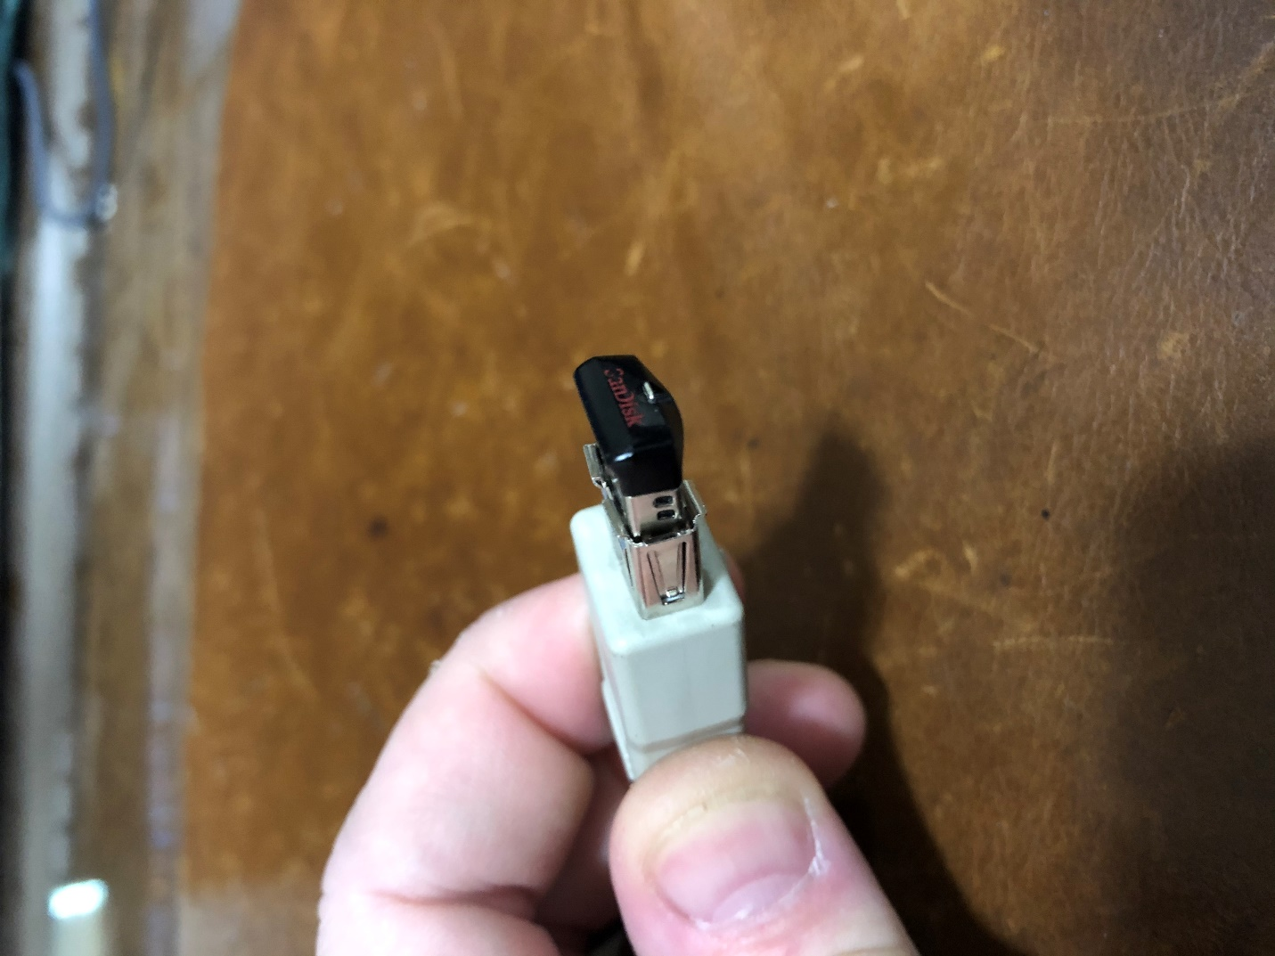

If it reads the USB and sees the music, you’re good. Go ahead and install the deck.
